**World Quant University**

**Professor: Ivan Blanco**

**Alpha Design I**

Nikolas Lippmann Pareschi - [nikolaslippmann@gmail.com](mailto:nikolaslippmann@gmail.com)

**Assignment: Unit 1**

**Question 1:** In this assignment, we want to evaluate how Disney performed as an investment between October 2008 and September 2013 and how risky it is. To do that we need to regresse monthly raw returns on Disney against returns on the S&P 500 over that period.

Download the historical data of Disney and S&P 500 over that period. Calculate the returns of Disney and the S&P 500 index.

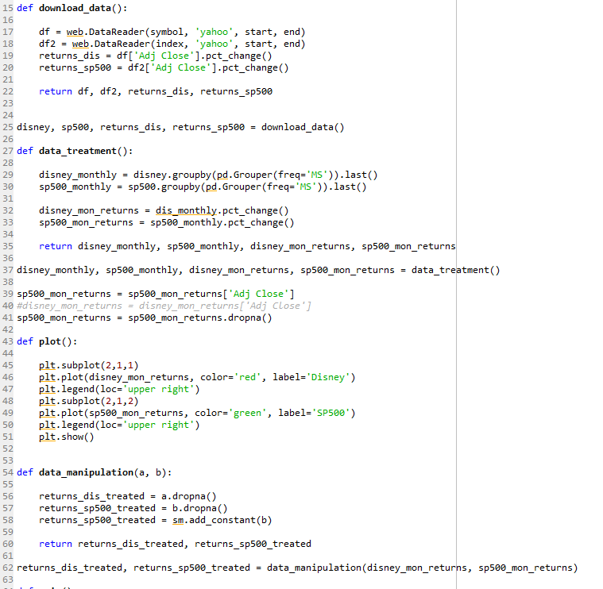



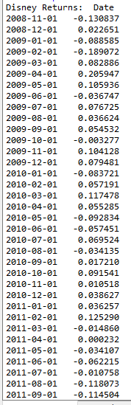 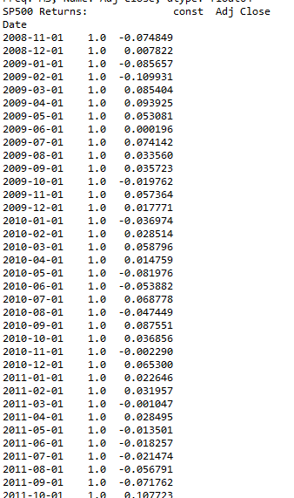

Using Python, plot the monthly returns on Disney against returns on the S&P 500 index from October 2008 to September 2013.

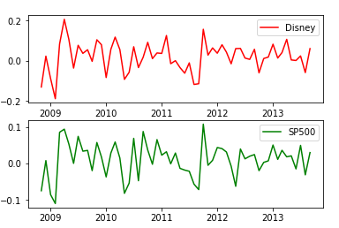

To answer the questions below we use the summary of the regression statistics generated in Python:

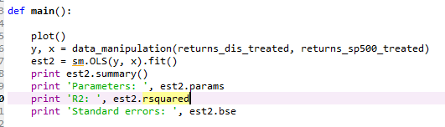

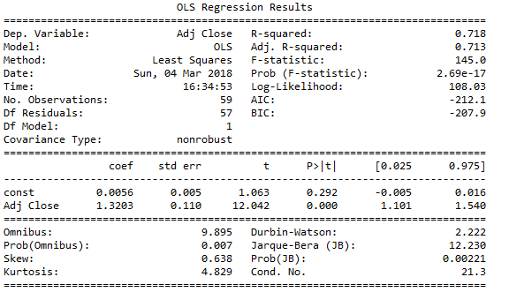

Find the regression line for Disney return on S&P 500 index What is the slope of the regression? What is the meaning of this value?

The regression line for Dinsey Return on SP500 index is:

Disney Returns = 0.0056 + 1.3203*(Sp500 monthly returns)

Its slope is 1.3203and it means that Disney has a a higher systematic risk and is expected to return more than the overall market (SP500). In other means, its Beta is higher than 1.

What is the Intercept of the Regression? What is the meaning of this value? Does Disney’s stock perform better or worse than expected? Why?

The intercept is 0.0056. This means that by the CAPM Disney stock perfomed better than expected. The reasons can be for example a change in the way the business is managed. For example, Disney is attacking young adults and even some men with the Star Wars movies.

Find the annualized excess return?

As the period was a full throttle quantitative easing, we had zero yields for T-bills on that period so the annualized return is the excess return is the mean annual return of:



What is the R squared of the regression? What is the significance of this value?

The R-Squared is 0.718. It means that our regression equation explains 0.718 of Disney stock movements. In other therms: R-squared = Explained variation / Total variation. Its significance is higher than the 99% level, as shown by the F-Statistic.

What is Standard Error of Beta Estimate? What is the significance of this value?

The standard error is 0.110 with significance higher than the 99% level (t = 12.042 with P> abs t = 0.000). Standard errors for regression are measures of how spread out your y variables are around the mean, μ. The standard error of the regression slope, s (also called the standard error of estimate) represents the average distance that your observed values deviate from the regression line. The smaller the “s” value, the closer your values are to the regression line.